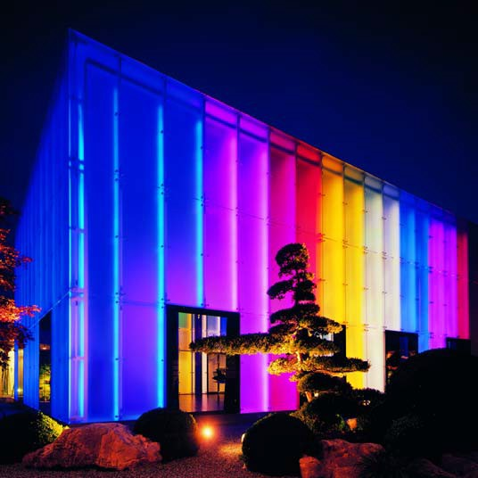
Fördergemeinschaft Gutes Licht

LED – Light from the Light Emitting Diode
17

LEDs are changing the world of light 1
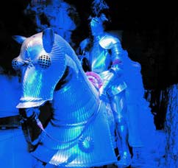

The LED light source 2

LED modules 6

Advantages at a glance 8

Typical applications 9

LED light in use 10

Operational and control equipment 20

LEDs and OLEDs: perspectives 22

Legal and normative requirements 24

Standards, literature 26
1

List of illustrations 27
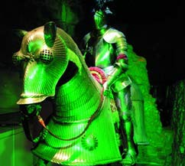

Imprint 28

Fördergemeinschaft Gutes Licht
publications 29

2
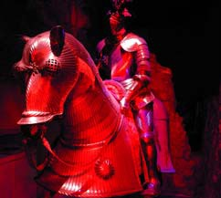

Title Illustration: LEDs bring colour into life. The illustration shows the hall of the
Weggis Hotel in Lucerne, Switzerland.
Over 84,000 individual LEDs are distributed on chains over its glass façade. With the
aid of a light management system every imaginable colour can be produced from the RGB pattern (see also page 15).

3

Light sources should be as small as possible, produce light efficiently and have a long life. The demands of architects, light planners
and operators of lighting in- stallations have formed the basis of the research and development work of the lighting industry. Today
more light sources with these properties are on the market than ever before in the history of artificial light. Until now, however, no fila- ment or discharge lamp has combined all three properties.

Only light emitting diodes (LEDs), also called light diodes, achieve this. They conform to the lighting designer’s ideal of a point- like light source: no other lamp possesses compara- bly small dimensions. The miniature form requires small optical systems and creates new demands for light guidance. In the LED, the light optical systems are made from synthetic materi- als with high refractive in- dices and replace the clas- sic metal reflector.

The light gains from LEDs continue to grow, doubling about every two years. They have today already ex- ceeded the values attain- able by halogen and fila- ment lamps. Soon they will be moving into the yield area of fluorescent lamps. It is not unrealistic to assume that in ten to fifteen years LEDs will become the sole front runner amongst effi- cient light sources.

Illustrations 1 to 3: coloured LED light has already quickly established itself. The rider is riding in Schloss Brake, the Weser Renaissance Museum; in the light itself, but more especially by using colour changes, he gains maximum attention from the audience.

With 50,000 operational hours, LEDs have a very long life. This results in a new conceptual approach to the design and develop- ment of lighting: there is
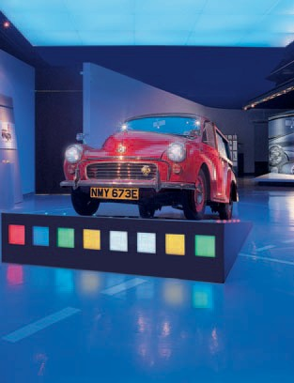

no longer a need for equip- ment for changing the light source: with LEDs, light source and luminaire grow old jointly and both are changed together when the lamp has reached the end of its lifespan – except in individual cases where repair of the light source
has to be possible.

The LED light source
began its career as a status symbol and has since become standard for car drivers, at first in the brake lights, later in the interior lights, soon after in the headlights and now today
in many traffic indicators.

The LED quickly conquered display and effect lighting
as well as gaining a firm foothold in lighting for ori- entation purposes. Now it is proceeding to desk, stan- dard and street lamps, making it available as ‘light to see by’. When luminaires with LEDs become an established component of
lighting concepts or when 4
they can even exclusively take over general lighting for the illumination system of a space, remains to be seen. It certainly will not be much longer …
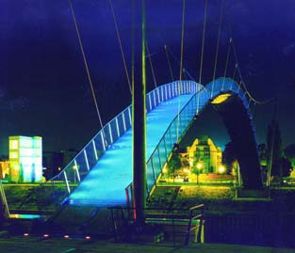

Illustration 4: the LED coloured surfaces and the LEDs on the ramp make the Morris Minor very eye-catching; the surface colours can be changed.

Illustration 5: an attractive night time picture of the bridge in Duisburg harbour, and also showing the light to see by, both the result of LED light on the railing posts.
5

In conventional lamps’ visible light arises as a by- product of the warming of a metal helix, or by a gas
discharge or by the conver- sion of a proportion of the ultraviolet radiation pro- duced in such a discharge. In LEDs the production of light takes place in a semi- conductor crystal which is electrically excited to illumi- nate (electroluminescence). In the largest available light diodes their dimensions
are represented by edges of about 1 mm. LEDs thus belong to the smallest available, almost point-like, light sources.

ted on plates which enable simple electrical contact and divert the heat: as LED modules (see page 6). The semiconductor crystals can also be mounted directly
onto the plates and be pro- tected by a light pervious covering.

The LED light
LEDs produce monochro- matic radiation and their colour tone is defined by the dominant wavelength. There are LEDs in the colours red, orange, yellow, green and blue.

White light can be pro- duced as a mixture of all wavelengths, for example in LED modules (see page 6). This arises through an ad-
ditive mixture of the three RGB colours
(Red, Green, Blue).

History of light production by LED

1907 The Englishman Henry Joseph Round
(1881-1966) discovers the physical effect of electro- luminescence. As at the time he was actually engaged in a new radio locating process for sea traffic the discovery is at first forgotten.

1962 The first red luminescent diode of type GaAsP comes onto the market. The industrially produced LED is born.

1971 From the beginning of the seventies LEDs are available in further colours: green, orange, yellow. Performance and effectiveness is continually being improved in all LEDs.

1980s to early 1990s High performance LEDs
(LED modules) in red, later red/orange, yellow and green become available.

1995 The first LED producing white light by lumines- cence conversion is introduced.

1997 White LEDs come onto the market.

Abb. 1
Alternatively, white light can be produced
by the conver- sion principle known in ordi- nary lamps (luminescence conversion).
Here the light of a blue LED ex-
cites luminescent material which
changes a part of the

the food industry, in the illu- mination of materials which fade easily or in the illumi- nation of sensitive works of art in museums.

Diagram 1: White light at various colour temperatures (in K = Kelvin) as a result of additive colour mixture.

Diagram 3: The colour tone and emission spectrum of LED light is determined by the dominant wave length.

As protection against envi- ronmental influences the semiconductor crystal is set into a housing. This is con- structed so that the light ra- diates in a semicircle of al- most 180 degrees (the cur- rent maximum is about 160 degrees). Guidance of the light is thus easier than in filament or discharge
lamps, which generally ra-
blue light into yellow. By overlaying the unabsorbed blue light with yellow light emitted by the luminescent material white light is pro- duced. The concentration
of luminescent material must here be guided pre- cisely so that the desired white is realised. Lumines- cent materials are perma- nently undergoing further development in order to improve the colour repro- duction value (see page 4)

white light

illuminating surface

conversion layer

diate light in all directions.
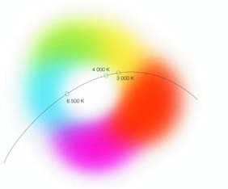

There are various types of housing for LEDs of low, medium and high perfor- mance; they all give good mechanical stability.

LEDs are only manageable by users if they are moun-
of white LED lighting.

Light emitted by LEDs con- tains no ultraviolet (UV) or infrared (IR) radiation. LEDs can therefore be employed anywhere where this kind
of radiation has a detrimen- tal influence, for example in
blue light
LED-chip

Diagram 2

Diagram 2: white LED light can also be produced with the aid of the conversion principle (luminescence conversion).

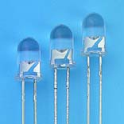
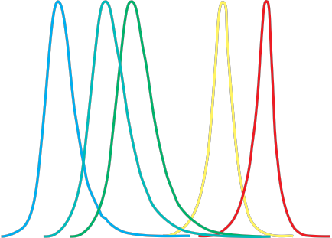

6 7 8


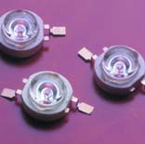

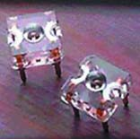

1,2

1

0,8

0,6
Watt

0,4
Spectra of white and coloured LEDs

0,2

0

380 430 480 530 580 630 nanometres

680

730

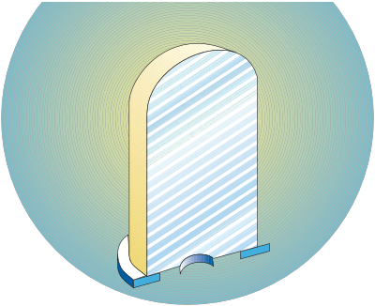
Diagram 3

9
Illustrations 6 to 8: LED housings (from left)
for low, medium and high performances.

Illustration 9: LED semiconductor crystal, on a carrier with electrical contacts.

LED functional principles
The light of a LED comes from a semiconductor crystal. It is electrically excited to produce light: two areas exist within the crystal, a n-conducting area with a surplus of electrons and a p-conducting area with a deficit of electrons. In the transitional area – called the pn-transition or depletion layer – light is produced in a recombination process of the electron with the atom with the deficit of an electron when current is applied to the crystal.

Diagram 4: tiny light diodes three to five millimetres in

Diagram. 4
The emission spectrum of the light thus produced is narrow banded. The dominant wavelength and the colour of the light depend on the materials used in the manufacture of the crystal. LED light contains no UV or IR radiation. The characteristic
current/tension curve of an LED shows a small differ- ential resistance in the flow voltage when compared to the lamp voltage, which makes it necessary to stabilise the working point. If the current supply is varied the luminous flux can be influenced in pro- portion. In practice a defined direct current is
allowed to flow through the LED which, as in a lamp using luminescent material, provides an operational device.

height – the principles of construction here are shown in sketch form – enables completely new light design.

Luminous Flux
The luminous flux value of currently available LEDs lies between one lumen
(lm) in low performance LEDs (about 50 to 100 mW power input) and up to
120 lm in high performance LEDs (up to 5 W). Stronger evidence for end users is the information on the lumi- nous flux packets which
can be realised with LED
modules.

Light colour and colour reproduction of white LEDs

LED Sodium vapour
high pressure lamps
Halogen-metallic vapour lamps
Lamps using luminescent materials
Mercury vapour high pressure lamps
Low voltage halogen filament lamps

Filament lamps

Efficiency of light sources

theoretical limit

White LEDs have above all a cold, neutral white light with a colour temperature
> 4,500 K, (K stands for Kelvin). Further develop- ment in the area of conver-
0 20 40 60 80 100 120 140 160 180 200 220 240
lumens/Watt (including series connection equipment losses)

Diagram 5



tible luminescent materials is making warmer light colours possible. Since
2003 there have been warm white (> 2,800 K) and neutral white (3,300 to
3,800 K) LEDs.

Convertible luminescent materials are also responsi- ble for an improvement in colour reproduction: warm white LEDs have a colour
and so making a contribu- tion to ecological relief. The same applies to external lighting, where long lasting LEDs (also coupled with solar cells) can be em- ployed in saving energy in stationary situations such
as road markings, or in mobile applications.

Lifespan depends on temperature
therefore be no build-up of heat in the operation of an LED: the conducting plate
or additional heat sink must reliably divert the heat.

A too high environmental temperature will equally lead to a decrease in the luminous flux.
Diagram 5: the light yield from LEDs is reaching ever higher values.

reproduction index from
Ra > 70 up to Ra > 90.
For cold white LEDs the Ra
value is between 70 and
80.

Efficient light sources LEDs are extremely efficient light sources. In 2005 the light yields from white LEDs had already reached values of over 30 lumens/Watt (lm/W), and those from coloured versions 50 lm/W. In the near future light diodes with yields of up to
100 lm/W will be available. LEDs will thus soon achieve the yield values of lamps which use lumines- cent materials.

Future generations of LEDs will find wide employment in interior lighting, lowering the use and cost of energy
The lifespan of an LED de- pends on its operational and environmental temper- ature. At room temperature LEDs – and thus also LED modules – have a very
long lifespan of up to
50,000 working hours.

In contrast to filament lamps, where a break in the helix means the end of its life, total failure of an LED is extremely rare. Its light intensity also declines much more slowly: this property is known as degradation. The period of degradation of the original luminous flux by up to
50 % defines the lifespan of
LEDs.

The degradation of the lu- minous flux is strongly de- pendent on the tempera- ture of the light emitting surface in the semiconduc- tor crystal. There must
The colours of the LED light

According to the type and composition of the semiconductor crystal the light from LEDs has different colours. Today there are white, blue, green, yellow, orange, red, and amber, together with nuances of these colours. The narrow banded (monochromatic) light is produced without additional filters. Examples are:

Semiconductor
material Abbreviation Colour

Aluminium-
gallium arsenide AlGaAs red

Aluminium indium gallium
phosphide AlInGaP red, orange, yellow

Gallium arsenide
phosphide GaAsP red, orange, Yellow

Indium gallium
nitride InGaN green, blue

Light intensity distribution of LEDs
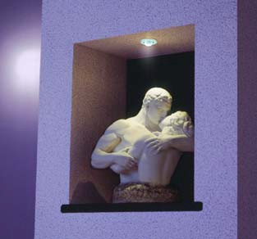

The light intensity distribution curves of LEDs are determined by the construction of the housing used. The semiconductor crystals are mounted on carriers which act as mini reflectors. The angle of radiation can vary between 15 and 160 degrees.

Light intensity distribution curve
(without secondary optical system)

100
90
relative intensity (%)
80
70
60
50
40
30
20
10
0
-100 -80 -60 -40 -20 0 20 40 60 80 100
angle of radiation in degrees

Diagram 6 10
Diagram 6: The light intensity distribution curve of the LED
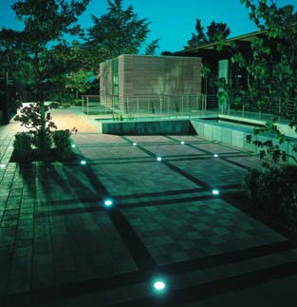

‘without secondary optical system’ has two peaks of intensity.
A high uniformity of illumination is achieved by the introduction of a diffusing plate.

Light intensity distribution curve
(with secondary optics)

100

80
relative intensity (%)

60

40

20

0
-40 -30 -20 -10 0 10 20 30 40
angle of radiation in degrees




Diagram 7
Diagram 7: An additional secondary optical system focuses the light from an LED. The result is a restricted spot of light.

Illustration 10: the point-like LED light is especially suitable for illumination – even in the smallest format.
11
Illustration 11: the light from ground mounted lights with LEDs which mark out the pattern of the site creates an interesting night picture.

An LED module consists of several semiconductor crys- tals or single LEDs (semi- conductor crystals with their housings) which are placed in series next to one an- other, or combined in some other form, on a conductor plate. The plate is not only
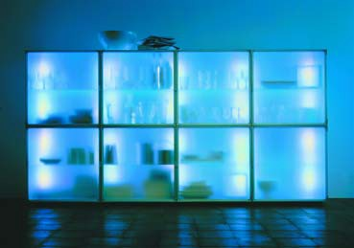

a carrier but also makes possible the easy fixing of the LEDs and other optical, electronic or mechanical components.

The electrical layout of the conductor plate can be adapted to a particular ap- plication: as well as single operation, coloured LEDs can also be separately fixed using an appropriate layout so that plays of colour and sequences are possible within a module. Colours
can be produced with an 12
additive colour mixture because the LED module combines the three RGB colours (red, green, blue). The mixing of basic colours leads to the creation of every favourite tone or to various colour effects.
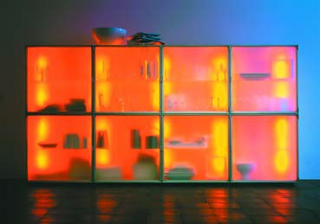

LED modules are obtainable on the market in differing shapes and sizes, the most important distinguishing fea- tures being their construc- tion technology such as:
• modules with wired LEDs mounted through holes on the printed circuit board.
• modules in SMD technol- ogy (Surface Mounted De- vice) – these allow for more miniaturisation than
is possible with wired
LEDs.
• modules based on innov- ative CoB technology (Chip-on-Board) – in these modules the semi- conductor crystals are placed directly onto a conductor plate and with contacts. This allows high equipment density, best miniaturisation and good thermal management for
a long lifespan.
• SMD or CoB modules for high performance LEDs (high performance mod-

ules) – high performance light diodes demand a module concept which makes possible the easy diversion of the heat aris- ing in the semiconductor crystal. For example, the conductor plate contains
a metal core made of alu- minium for this purpose.

Conductor plates are pre- pared from diverse materi- als. The range extends from

standard conductor plates
to those with organic mater- ial with interwoven threads for stabilisation and again to highly flexible foil material with a thickness of 0.15 mm or to ceramics, glass or metal core conductor
plates.

High performance modules
The high performance modules are especially

13
Illustrations 12 and 13: LEDs make it possible – living with light now also means living with coloured light.

innovative. The trend is clearly aiming towards these efficient light sources and to being able to re- place current general light- ing by LEDs in the near fu- ture. High performance modules with a light yield

in the region of 30 lm/W can in fact already be manufactured but as yet, however, some technologi- cal development remains
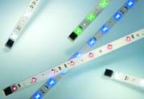

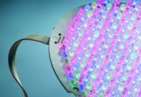

to be accomplished.

The most important aim of the LED manufacturers is to further optimise effi-
ciency. This must also lead to an improvement in the sale price/lumen relation- ship so that LED modules, which cannot currently
hold their own with cheaper conventional means of lighting, become a force to be reckoned with.

Further efficiency increases
Due to the higher perfor- mances of LED modules
an increase in efficiency by means of optical compo- nents is becoming ever more important. Above all these will be improved by the integration of optical technology, as for example nano-structured semicon- ductor surfaces, special chip design and optimised reflector/micro-optic sys- tems within LEDs, as well
as by the use of special

14 15
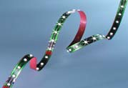
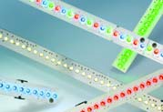

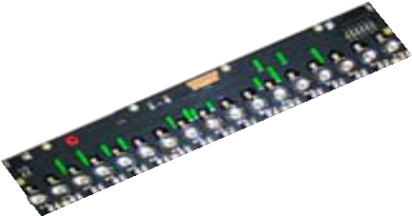
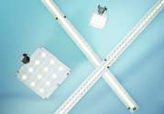
16 17

materials such as optical polymers.

Illustration 14: module with wired LEDs.
18 19

LED modules – light sources with

Another important aspect of high performance mod- ules is thermal manage- ment. Heat affects the wavelength of the light ra- diated by LEDs and thus also it’s colour, as well as the life of the light diodes. This decreases with rising temperatures. The currently available thermally opti- mised designs can and must be improved in view of the higher performances of LED modules.

The colour reproduction properties of high perfor- mance modules with LEDs will steadily be improved by optical and thermal converter optimisation and specially calculated mix- tures of suitable LED spectra.
Illustration 15: module in SMD (Surface Mounted
Device) technology.

Illustration 16: high flexibility module in SMD
technology.

Illustration 17: module based on innovative CoB (Chip-on Board) technology.

Illustration 18: high performance SMD module. Illustration 19: high performance CoB module.
advantages

The essential advantages of LED modules as compared to conventional light sources:

• They have a low profile.
• Their beam is IR free. LED modules therefore radiate no heat in the direction of the illuminated object.
• They have a very long life.
• The semiconductor crystals inte- grated into the module or individual LEDs can be directly controlled,
thus reacting very quickly, and are easily dimmed even in RGB (red, green, blue) phases.
• The high lamp density and compact- ness of LEDs opens up completely new possibilities in optical design: from secondary optic and reflector systems to aimed light guidance and homogenisation of light ray distribu- tion.

Illustration 20: blue LED
light decorates the hall with an accent on colour at the Millenium Point in Birmingham, England.

20
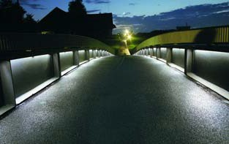

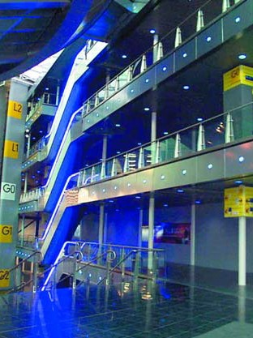

21
Illustration 21: LED light shows the way over the bridge.

LEDs offer a multitude of new possibilities and some- times also demand other ways of thinking with re- gard to lighting. The reports of success published by manufacturers cause the popular press to speculate time and again as to when the new ‘semiconductor lights’ will have superseded the well known forms of lighting. The assumption
that in the future LEDs will replace some of the classic lighting is not unrealistic. Above all, however, they open up additional uses, which until now have been difficult or very expensive
to achieve.

LEDs and LED modules combine many advantages. Their success is based on making new applications accessible and on their employment in conven- tional illumination work.

Economic advantages
• A very long lifespan of up to 50,000 hours means that the lamps in a light- ing installation are com- pletely maintenance free in most forms of applica- tion. The maintenance costs of the installation
are reduced.
• The high degree of effec- tiveness of coloured – and in the future white LEDs – gives rise to low energy use. Energy costs fall.

Advantages for design, architecture and lighting arrangements
• Coloured light can be produced directly and effectively. It has a rich fullness of colour and the choice of colours is im- mense as all possible tones can be mixed to- gether.
• There are LEDs with high value white light pro- duced by an additive colour mixture (RGB mix- ture) or in a blue LED coated internally with lu- minescent material (lumi- nescence conversion).

The latest development is LEDs with warm white light (3.200 K colour tem- perature).
• LEDs have no UV or IR radiation in their spec- trum. This means that even sensitive objects are not put under stress and can be illuminates at
close range.
• The small cross section makes for very compact luminaires and large re- flectors can be dispensed with.

Technical advantages
• LEDs have high func- tional safety.
• In technical terms LEDs can easily be dimmed – over the whole range from 0 to 100 percent.
• Colour control of the
RGB colour mixture is
also technically uncompli- cated .
• LEDs are durable against impact and vibration.
• Instant start enables smooth switching.
• Focused light of high in- tensity can be produced with LEDs.
• LEDs can be operated at low voltage, even when starting up, they are safe if a fault occurs.

Advantages for the environment
• The low energy use of coloured, and in future white, LEDs reduces energy costs in operation and the heat gain for air- conditioning.
• The long life of LEDs means that there are fewer old lamps to be disposed of.
• An important environ- mental aspect of external lighting: the orientation
of insects that are active at night is not disturbed by LED light. Animals react almost imperviously to its spectral composi- tion.

LEDs are today almost irre- placeable as signs of status and importance in the field of electric and electronic equipment. They are in- creasingly establishing themselves in other areas, particularly in markerand orientation lighting as well as in the illumination of ar- chitectural and other ob- jects. There have as yet been few attempts at light- ing in the workplace and general lighting is still a
dream of the future: this ap- plies similarly to external lighting.

Typical applications of LEDs and their most important advantages are:
• Signal installations, traffic lights
High light intensity (good visibility), directly pro- duced coloured light, very high operational safety, long lifespan (minimal maintenance)
• Lighting in the auto- motive industry: instrument/display lighting, indicators, driving lights
Direct operation at low voltage allows easy integration into the on- board system, coloured light, long life (no bulb changes)
• Lighting for orientation Coloured light, coloured zones and simple switch- ing options (including colour change) raise

attention and reduce the risk of accidents
• Effect lighting, advertising, staged lighting
Coloured light, dimmable, simple to switch and con- trol
• Display lighting, display background lighting Extremely compact dis- plays possible, low operational temperatures
• Safety signs for emergency routes
High reliability, immediate start, easily controllable
• Display case, museum and shop lighting Illumination of sensitive objects at close range with IR and UV free light
• Integrated compact lighting solutions: handrail lights, lights set into the floor, stair lights,
wall lights, furniture lights. Compact lamp construc- tion, low operational temperatures (hand touchable)
• Lights in the workplace –
industrial applications, for example machine lighting
Compact lamp construc- tion, firm against vibration, IR free light, long lifespan
(minimal maintenance)
• Desk lighting
Compact lamp construc- tion, IR free light
• Illumination
Illumination of sensitive objects at short range with IR and UV free light,

details can be highlighted well
• Underwater lights
Low voltage operation, high safety, long life (no maintenance)
• External lighting Qualitatively high value white light, reduced energy costs, long life (minimises maintenance)

22
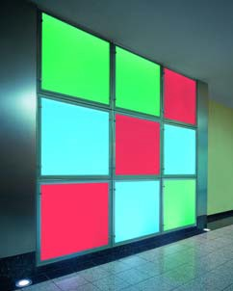

Illustration 22: light to look at – coloured board with colour changes in a hotel reception area.

Illustration 23: Machine lighting brings LED light of 500 Lux to where it is needed.

Illustration 24: LED lighting inte- grated into the handrail is inno- vative – an application problem which until now has been very difficult to solve and which was very uneconomic in the few cases in practice.
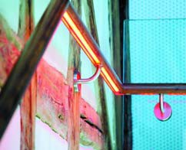

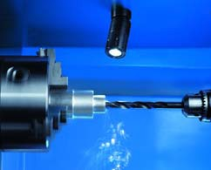

Emergency and safety lighting
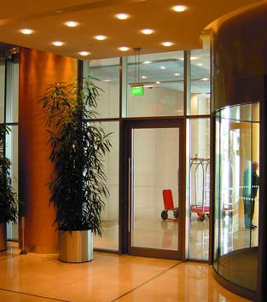

A power cut means sudden darkness. This creates anxiety and seeing is al- most impossible. A lighting system independent of the grid, which can be
switched on immediately in case of emergency, makes orientation easier and

Illustrations 25 and 26: LEDs are especially well suited for emergency sign lighting.
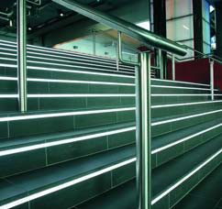

25

makes it possible to leave the affected building in safety. Illuminated/back- ground-lit safety signs can be used to mark emer- gency routes. LEDs are es- pecially suited to this latter purpose; they fulfil all the standard requirements and thus ensure good visibility of the signs. LEDs are gen- erally well suited for emer- gency and safety lighting because they are very reli- able, start up immediately and can be easily con- trolled.

Stairs and corridors: reduce the risk of stumbling
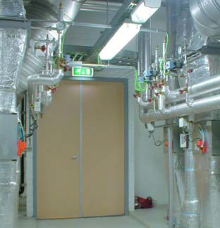

The risk of accidents is par- ticularly high on stairs. Going up and down is
safer if the treads are dis- cernible at close range and their further course is easily visible. Light reaches the treads almost without loss if it comes from lamps built into the riser: for example
in the theatre (Illustration
28), but also in any other stairway. For this purpose there are luminaires of nu- merous types of construc- tion, of which several can be built into the riser. With- out LEDs the illumination of
the edge between the tread
27
Illustration 27: illumination of the edge between stair tread and riser is easier with LEDs than with any other form of lighting.

and the riser is quite diffi- cult to achieve.

Orientation and marker lights naturally also make sense even if the way is not interrupted by steps: for example in long corridors (Illustration 29). Here too built-in LED lights, either in the wall or the floor, are the first choice.

Illustration 28: In a theatre the light for the stair treads is of great importance for safety.
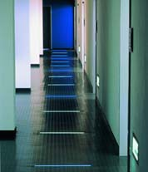

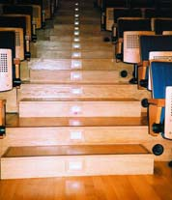

Illustration 29: LED lights mark the corridor.

Planned colour
Colour has made a dra- matic impact on architec- tural design. The use of colour and the almost limit- less palette available from LED’s creates a colourful fascination that is mirrored by the use of dynamic colour change from red to green to blue and to all the colours of the rainbow.
28 29

Illustrations 30 and 31: this coloured surface with a dynamic colour change is a visual highlight for guests in the Lufthansa business lounge in terminal 2 at Munich Airport.
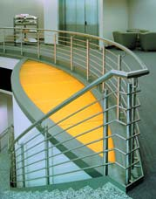

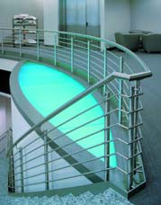

30 31
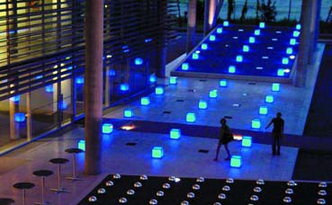

Illustration 32: Eye catching scene in the approaches to the reception area of a Swiss insurance undertaking – LED lamps with blue light.

Colour guides the eye Colour can act as an opti- cal stimulant. This applies especially to colourfulness in places where colour is (still) somewhat unusual. The effect is even stronger if a colour change is per-
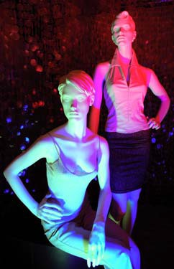

ceived as movement. In the advertising business colour has long had an estab- lished place as an eye- catcher in display windows and salerooms. This world
is becoming even more

brightly coloured with LED
light.

Illustration 33: the display window dummies are constantly being remodelled as the light changes colour. Three diffusely radiating lights are being used to produce colours on the RGB pat- tern in a synchronised sequence. White/neutral is the lightest, at a lighting intensity of 160 lux, followed by green with 76, red with 68 and blue with 59 lux.

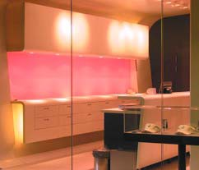
33 35
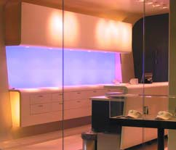

Illustration 34: un-missable – the LED light band marks the course of the glass doors. A colour change guides the gaze to the Munich municipal shop premises.
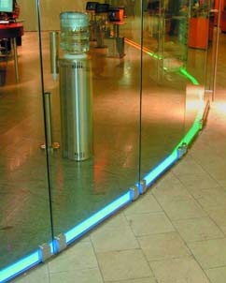

36
Illustrations 35 and 36: the illu- minating surfaces attract the gaze, and the impressive colour change raises the attention
level even more. The display of goods and the remainder
of the saleroom are by contrast decorated with restraint.

Colour relaxes
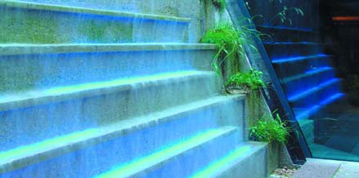

Wellness has a lot to do with relaxation. Lighting moods produced by coloured lights can promote the relaxation process; health teachers
from Asia know this for a fact. Coloured light to relax by can, for example, be used as a component of light therapy and as an element of space design in, among other things, the fit- ness studio. It can also be employed to provide a sim- ple, changing space/colour environment which viewers can contemplate anywhere where tension needs to be relieved, such as in a wait- ing room or examination
room at the doctors. 37
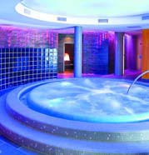

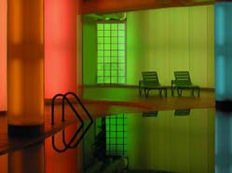

Illustration 37: look and relax – the water wall in the wellness rest area at the Krallerhof Hotel in Leogang, Austria.

Illustration 38: In or by the
water, the relaxing colour of the whirlpool makes an impression on every visitor to the Krallhof Hotel.

Illustration 39: Visitors to this fitness studio experience well being in a sea of colour.

38 39
LED light – UV and IR free LED light contains no ultra- violet (UV) radiation; there- fore the constituent material of any objects illuminated does not fade or become
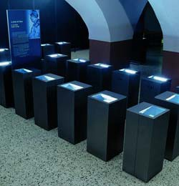

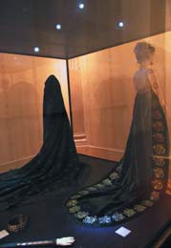

hot under the light beam.
The lack of infrared (IR) radi- ation also permits the illu- mination of heat sensitive materials – regardless of whether they are in a mu- seum or in display windows and salerooms.

Illustration 40: In a museum UV and IR free LED light exhibits Napoleon’s coronation cloak and the empress Josephine’s dress.

Illustration 41: Whether in a museum or a saleroom, LED
light is particularly well suited for the illumination of goods in dis- play cases.

Colour adds value Colour adds diversity, colour guides the eye, and colour relaxes – and thereby really adds to the
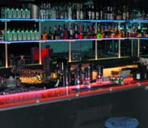

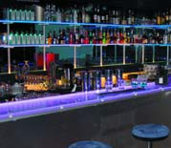

ambience of a location. Inns and restaurants pursue this aim by installing dynamic, changing LED light, be it in the floor, on the walls, in the ceiling or in the fittings, for example at the bar.

42 43
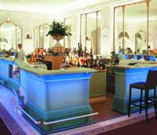
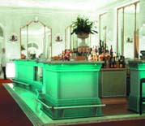

44 45
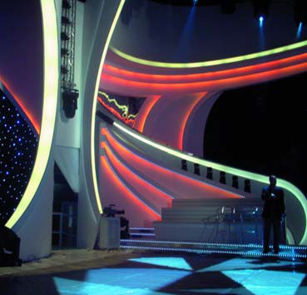

Illustrations 42 and 43: colour change at the bar counter …

Illustrations 44 and 45:
… or – with a more long range effect – guides the eye beneath, giving a relaxing and high
quality feeling.

Colour is fun Colourfulness and colour change are also a means
of fun. This becomes espe- cially clear in the lighting effects in discotheques and other public rooms. Where until now only the ‘colour organ’ produced flickering flashes of light, colours can now be displayed in a
fuller, more extensive and programmed flow which also gives a calming effect.

Illustration 46: stage set for a television show of the Italian broadcaster Mediaset.

Coloured LED light with external effects
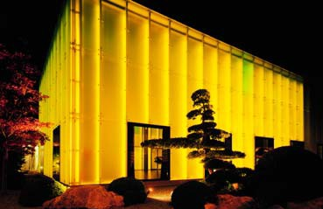

Much (coloured) light for little energy and thus not associated with excessive costs – these advantages of LEDs can be used in a
variety of ways for instance to give buildings a ‘night view’.

A unique example is the extension of the five star Weggis Hotel in Lucerne, Switzerland, with a translu- cent double glass façade;
it was opened in 2002 and can be used for events or as a restaurant (Title Illus- tration, Illustrations 47 and
48).

The LED chains which are distributed over the façade from the inside are each
840 metres long – this re- presents about 84,000 indi- vidual LEDs. All imaginable colours on the RGB pattern can be produced by a light management system – for
a single or multicoloured coloured façade, for the colourfulness of the interior space according to the de- sired light mood and to suit specific events.

Another example is the
‘night view’ of an office block in Lemgo, North Rhine-Westphalia. The glass façade lights up in red, green and blue whilst in the hours of darkness after close of business the office rooms behind are bathed in these colours (Illustrations 49 to 51). Synchronised LED light tubes indirectly illuminate the offices with colour.

47
Illustration 47: the hall of the Weggis Hotel in Lucerne, Switzerland, lit up by 840 metre long LED chains in all desired colours – for example, all in
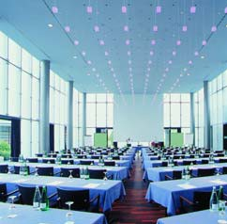

yellow or multicoloured, in the colours of the rainbow (see Title Illustration).

Illustration 48: internal effect of the façade at the Weggis Hotel.

Illustrations 49 to 51: the ‘night view’ of an office block changes colour: the office rooms behind are bathed in these colours
in the hours of darkness after close of business.
48
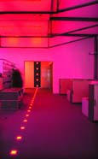

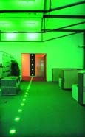

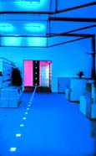

Façade lighting
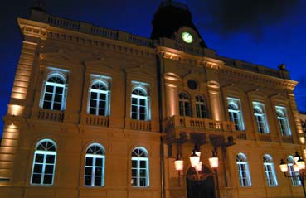

In order to illuminate façades, either interior light- ing is used or they are lit from outside.

With the ‘inside’ option, the available room lighting can be programmed to good effect. Another possibility is to set up the lighting with, for example, specially in- stalled coloured light as in an office building (see Illustrations 49 to 51, page
15) or behind a glass facade (Title Illustration and Illustrations 47, 48 on page
15).

With illumination from out- side, luminaires are either mounted close at hand
52 (hard shadows) or at a greater distance from the building. Alternative: inte- gration of a lighting system into the façade. LEDs are particularly suitable for this: for example in wall lights, for illumination, as a light
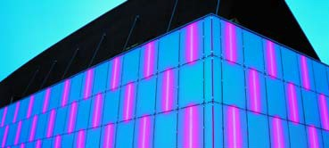

object (also in colour) or for an outlining light effect hid- den behind a wall projec- tion or something similar.

Coloured light surfaces or light figures are also effec- tive. These applications, which are easily produced
53 with LEDs, can also be used for advertising with light.
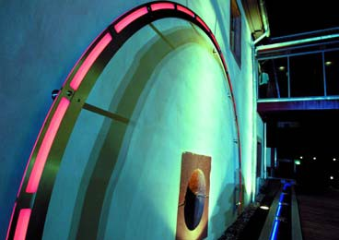

Illustration 52: integrated illumi- nation – LEDs are well suited to façade illumination.

Illustration 53: Coloured LED light and colour change on the façade throw the Dortmund Concert Hall into relief against the cityscape.

Illustration 54: coloured LED light and colour change symbol- ise the mill wheel at the Buhl- schen Mill in Ettlingen. As a cen- tral light figure it complements both the other elements of the illumination: searchlights set
into the ground for light cones on the façade and a blue LED line along the course of the brook in front of it.

Step by step safety
The danger of stumbling on stairs lessens when the treads are easily recogniz- able. This goes for inside (see page 10) as well as for outside. The best solution is to build LED lights into the risers.

Attention! – LED light from below
LED lights set into the floor are used principally to in- crease safety: their coloured lights mark dan- ger spots, for example the approaching tram (Illustra- tion 55), or the edge of the platform (Illustrations 58 and 59).

Illustration 55: the light hurrying before it makes passers by aware of the approaching tram.

Illustration 56: a well lit stairway connects two areas of a hotel and leisure facility. The LED light provides good sight of the
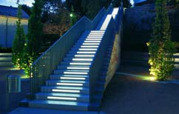

treads for going up and down the stairs whilst from a distance the lit stairway has the effect of a light object.

Illustration 57: light for steps:
in the ‘Welle’ office complex in 56
the centre of Frankfurt on Main visitors to the numerous catering enterprises are safe while on their way.
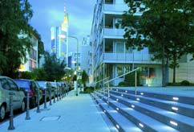

Illustrations 58 and 59: whether on the underground in Stockholm (above) or the rapid transit in Prague (below) LED light draws attention to danger
on the platform. In Prague, when an approaching rapid transit
train is announced the LED light flashes; on arrival it illuminates continuously but is switched off where there are open doors.
57
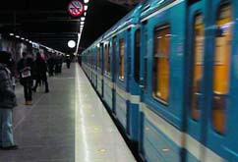
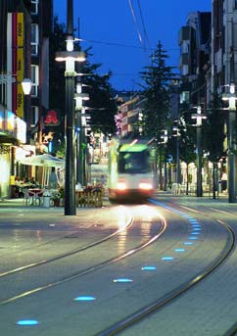

58

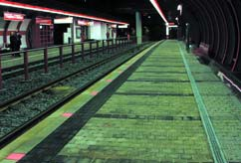

LED light shows the way LED lights set into the ground mark the way and make orientation easier. They are equally suited as an element of architectural design and a decorative accessory.

Illustration 60: light lines – route guidance in the estate park at the Hohenkammer Academy.
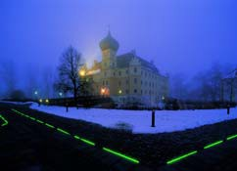

Illustration 61: decoration and orientation at the same time – LED lights set into the ground at the ‘Welle’ office complex in Frankfurt on Maine.

Illustration 62: Light lines decorate the terrace of an espresso bar.
60
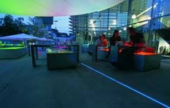
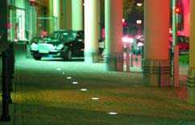

61 62

LED light with long range effect
The strong illuminating power of LED lights makes prominent points into fea- tures visible over a long distance. The illuminated wind turbines on the
Haarstrang between Mun- ster and the Sauerland are reminiscent of huge blos- soms. At the same time the LED light fulfils safety duties in signalling the presence
of the high wind turbines. The second example: the
Stone Bridge in Regens- burg. On the occasion of the city’s application to be- come the 2010 culture cap- ital the bridge received a red appearance suitable as
a symbol for the bridging of space and time.

Illustration 63: the Stone Bridge over the Danube in Regensburg in LED red.

Illustration 64: Wind turbines in red – put into practice with LEDs.
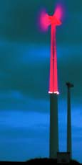

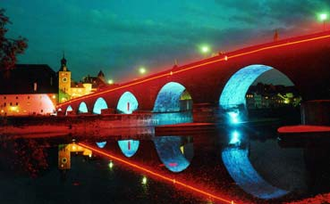

Street lighting with
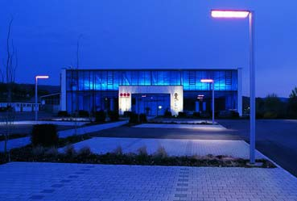

LED light
There are also ‘proper’ LED luminaires for external lighting: road and street fix- tures which project the light from the LEDs to where it
is needed. LEDs show their suitability for street lighting: accidents are scarce and there are few lamp changes, little maintenance, reduced energy use and low costs.

LED lights set into the ground can also mark routes traversed by motor vehicles, for example ac- cess roads and entrances. On public roads in Milan, Italy, LEDs have now been used for the first time to mark traffic islands (Illustra- tion 68).
65
LEDs are very suitable in tunnels (not pictured) for orientation lighting which, at the same time, provides additional safety: along the road embedded LED light bands are increasingly being installed in the walls or in the asphalt beside the carriageway itself.
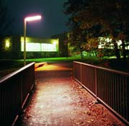

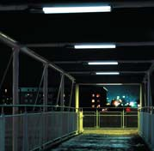

Illustrations 65 and 66: probably the first street lights with LEDs
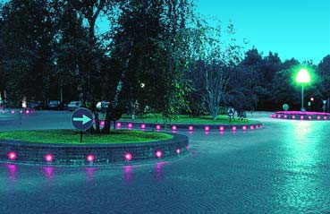

– in a car park (above) and on a cycle way (middle left).

Illustration 67: footpath lighting, here a bridge with external LED lights.

Illustration 68: beware roundabout traffic – the red LED light has high attention value.
66 67

Operational equipment should
• provide the energy sup- ply appropriate to type (safety-low voltage SELV),
• guarantee safe operation under various environ- mental conditions,
• enable stability or control- lability of the technical
light parameters,
• have an interface for spe- cial applications and
• be as flexible as possible in use.

Frequency changers
At the present time there are two sorts of frequency changer for LEDs and LED modules in performance classes from 3 to 500 Watt:

• frequency changers which reduce the electri- cal supply of 230 Volts to a stabilised low voltage
of, for example, 10, 12 or

24 Volts (constant current regulation to the module) and

• frequency changers which reduce the electri- cal supply from 230 Volts to, for example, 30 Volts and supply a stabilised current (fixed currents are about, for example, 350
Milliampere (mA), 700 mA, 1,050 mA). In this case it is possible to switch the LEDs in series up to a maximum no- load voltage.

All frequency changers available on the market, which meet the relevant safety specifications, pro- vide for separation from the grid by the use of an inter- nal transformer. Unearthed LED modules can therefore be touched without fear of an electric shock. A protec-
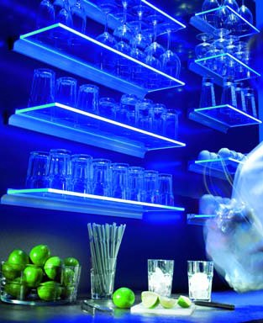

69

tive level (IP code) must be defined and given for every frequency changer.

For safe working methods with an LED frequency changer it is also important that the maximum permit- ted casing temperature is held at a certain test point. In qualitatively high grade frequency changers, the casing temperature test point ‘tc max’ is defined
and shown on the casing.

A further trade symbol for temperature protection is the specification of the maximum temperature in a triangle. This specification certifies that the equipment referred to is provided with a device for protection against overheating and that the surface tempera-
ture of the casing will never exceed the value shown in the triangle.

Control
In accordance with the type of operation there are two different methods of control for LEDs and LED modules: voltage regulated and cur- rent regulated.

Voltage regulated
The voltage regulated con- trol of LEDs is charac- terised by the fact that the diodes are operated with a constant voltage. In this case standard proprietary “direct current” equipment can therefore be used as the power supply. This method of operation per-
mits easy control of light in- tensity in LEDs by pulses (switching on and off) of
the power supply. With this method it is necessary to limit the current in LEDs, because the forward ten- sion leaks strongly. An in- correctly defined operating

Illustration 69: the coloured
light comes from the aluminium profiles carried by the glass plates; up to 48 LEDs fit into each profile.

current limit can lead to de- struction of LEDs and their operational and control equipment.

Current regulated
The current regulated con- trol of LEDs has advan- tages for constant operation and in the performance balance (lumens/Watt). For this purpose a predeter- mined current at which the LEDs should be operated is defined. The appropriate wiring, in most cases in- cludes a governor, ensures constant operation. Strongly fluctuating forward tensions play only a small role in
this method of operation as the voltage to the LEDs ad- justs in proportion to their operational current so that they are not overloaded.

Control of light intensity There are several proce- dures for brightness con- trol:

• control with the aid of analogue regulated con- trol elements (transistors) in which these are oper- ated as a variable resis- tance.

This procedure has two disadvantages: at low light intensity the control element has a relatively large performance loss which is converted into heat. Because of this a component for an appro- priate diversion of the heat has to be included and this is of relatively large dimensions.

• control with the aid of digitally controlled switches.

Here the LEDs are switched on and off inter- mittently. This happens
so often within one sec- ond that the eyes do not notice the flickering of the LED light.

Control by pulse with modulation is, for exam- ple, such a process.

If the technique of bright- ness control is combined with the technological op- tion of being able to set various coloured LEDs to individual colours, then colour sequences and plays of colour, as well as mixed colours, are very easily created.

Wiring of LEDs
Two of the most frequent types of wiring – in each case combined – are return conduction and the feeder line.

• Combined return conduc- tion (earth):
For this, expensive drivers are necessary, although integrated drivers with safety switching are al- ready available. This
raises the cost. Drivers are also relatively slow (only usable with low phase rates). The voltage to the LED modules can be switched off in cases of failure.

• Combined feeder line
(plus):
The available integrated drivers with safety switch- ing can be easily con- trolled with simple tran- sistors or field effect tran- sistors (FET). This re- duces costs. If faster switches are used then it is possible to set high phase rates.

Control interfaces
The possibilities for bright- ness control already de- scribed can be used with control devices previously developed in conventional light technology.

Analogue interfaces belong to the technically simpler systems, for example the
1-10 V interface. Here the applied analogue control voltage appropriate to
the control equipment is converted into an adequate signal for supply to the LEDs.

Manual control equipment also as a rule counts among the group of sim- pler systems. Here there is
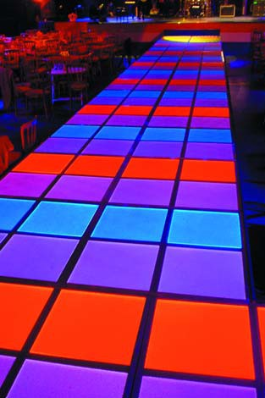

frequently equipment with a limited range of functions, where colour sequence processes or colours can
be adjusted by press keys. In more expensive equip- ment of this class it is pos- sible to bring in separate, simpler colour schemes.

Among the more expensive systems also suitable for use in larger installations there are, for example, the digital multiplex transmis- sion process DMX, the standardised digital inter- face DALI (Digital Address- able Lighting Interface) and the digital European Instal- lation Bus EIB. These sys- tems can control a large number of control circuits (colour channels) via a small number of lines, both individually and indepen- dently, over fairly long dis- tances.

70
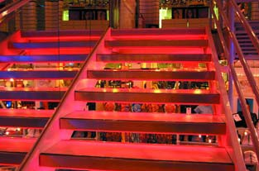

Illustration 70: catwalk and dance floor are shown in rich colours.

Illustration 71: eye catcher –
the red light makes the stairway unusual.

White LEDs under way As well as coloured LEDs which now already occupy a firm place, LEDs with white light will in future be used in ever greater num- bers for illumination pur- poses. Research must, however, make its contribu- tion by increasing the light yield of white LEDs to 100 lumens/Watt (lm/W). Along with this goes a continual improvement of the quality of white LED light. Defined colour temperatures with narrow tolerance limits and a high colour reproduction
index of at least Ra > 80 or even Ra > 90 for all white LEDs are also a part of
this.

Further developments ac- company the increased use of LEDs as an alternative
to more usual means of lighting:
– Besides increasing the light yield, research is also focusing on the op-
erational temperature and its effect on lifespan. In
the near future, develop- ments will make available LEDs suitable for operat- ing at temperatures

Illustrations 72 to 74: the colour change dramatises the glass front and façade.

higher than those cur- rently possible. The ex- penditure currently nec- essary for heat diversion will therefore be greatly reduced.
– The foreseeable exten- sion of production capac- ity and greater number of units in production will contribute towards mak- ing LEDs cheaper.

Organic LEDs
Another revolutionary
means of lighting for the fu- ture is organic LEDs
(OLEDs). They will soon open up other types of lighting. Today they illumi- nate displays on electrical household goods and mo- bile telephones. Research has, however, already pro- gressed so far as to make it foreseeable that in a few years time OLEDS will be available as flat light
sources for innovative light- ing solutions.

If traditional ways of think- ing permeate this kind of lighting solution, lit ceilings offer a good example of the use of OLEDs: they can be produced to a considerably smaller construction depth. And: the uniformity of the lighting effect is no longer determined by the lumi- naire optics but is more or less controlled by the
lamps themselves.

The OLED light source Organic LEDs (OLEDs) are today normally constructed on glass substrata. Other components are the light producing layer, the elec- trical contacts and the cas- ing for protection against external influences. Efficient prototypes are evidence
that it is possible to pro- duce flexible light sources based on a mouldable transparent substratum.

Research on materials has discovered a series of systems in which light can be produced. The results reveal two groups: organic LEDs with small molecules (sm-OLED – small mole- cule OLED) and those with long molecule chains, the polymers (p-OLED – poly- mer OLED). They are mainly differentiated by the number of materials necessary to construct the light producing layers. In sm-OLEDs the organic component consists of four
layers: the same functional- ity can be already be re- alised with two layers using p-OLEDs.

Coloured and white
OLED light
Colours from every area of the visible spectrum can
be produced using the cur- rently known organic mate- rials. This includes white.

The particular advantage of OLEDs: the white light so important in general light- ing, can be produced by a light mixture in the organic layer.

Using this method of light mixture, white and coloured OLEDs which are com- pletely transparent when switched off, can be manu- factured. The production of transparent OLEDs is very simple but their light can, however, only be dimmed and not changed in colour.

The mixture for white light makes it possible to adjust colour temperatures be- cause distinct organic lay- ers are used to produce the three basic colours. Such OLEDs hence offer possibilities for the design of colour sequences.
Alternatively white light can be produced with the aid of the conversion principle, exactly as with inorganic LEDs (luminescence con- version, see page 2). To do this in OLEDs, blue light from the organic layer is mixed with the yellow light from a luminescent conver- sion material. If white light
is produced in this way, then the light source is not transparent when switched off.

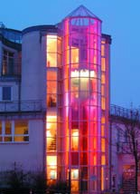
72 73 74
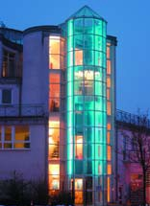

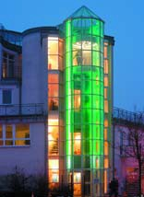


OLEDs, which are con- structed from single, indi- vidually controllable points, offer maximum flexibility in the production of colour and in dimming – however at very high cost. In future solutions to this problem information could, for ex- ample, be presented on illuminating surfaces.

LIGHT

glass substratum

getter

Diagram 8: principle of light production with organic LEDs.

Diagram 9: schematic represen- tation of the functional
principles of OLEDs – the organic layer of sm-OLEDs consists of four coatings. The same functionality can be achieved in p-OLEDs with two
adhesive screen organic layers cathode layer anode (ITO)


Diagram 8
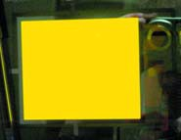

glass substratum anode (ITO) organic layer
electron injector
electron conductor
emitter
‘hole’-injector

coatings.

Illustration 75: prototype of an
OLED, whose organic layers are mounted on a glass substratum.

Illustration 76: LEDs are on the way to becoming the future means of lighting.
metal cathode getter

sm-OLED

polymer emitter
PEDOT

p-OLED

Diagram 9 75
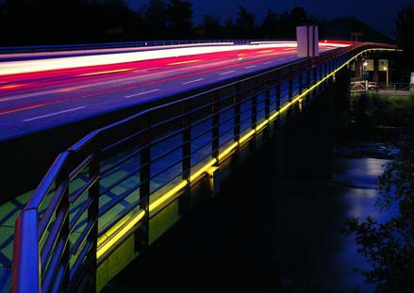

EU guidelines Manufacturers and import- ers may only bring prod- ucts which fulfil the basic demands of European guidelines into circulation in the European Union
(EU). For luminaires, the
Low Voltage Directive (LVD), the General Production Safety Directive and the Electromagnetic Compati- bility Directive (EMCD) are binding.

National law
The European requirements must be assimilated into corresponding laws of the land in the various Member States. In Germany the Low Voltage Directive and the General Production Safety Directive are transformed to the Geräte- und Produkt- sicherheitsgesetz (GPSG). The EMCD-Directive is imolemented by the Ger- man Gesetz über die Elek- tromagnetische Verträglich- keit von Geräten (EMVG).

CE Marking
The CE marking on prod- ucts is the manufacturer’s declaration that a product conforms to the essential re- quirements of the European legislation. The manufac- turer must produce proof of conformity to these guide- lines by means of an evalu- ation process whose docu- mentation must be made available on demand to the responsible authorities.

By the CE marking the manufacturers certify on their own responsibility that their products conform to the essential requirements of the relevant EU Direct- ives.

The CE marking does not document conformity to the laid down standards. ‘CE’ is not, therefore, a test mark.

The CE marking does not document conformity to the laid down standards, but only the essential require- ments of the Directives. Therefore, the ‘CE’ is not a test mark.

As with all other electric lights, LED luminaires can only be placed on the market if they have the CE marking.

Lighting installations with LEDs for special effects can additionally fall under other legislation such as the Toy Directive, Medical Products Directive etc.

Production Safety
The GPSG obliges manu- facturers only to bring into circulation products which are so made as not to endanger the health and safety of the user or of a third party. This applies not only to uses for which the product is intended but also to foreseeable cases of misuse.

The manufacturer confirms conformity to standards ei- ther by a ‘manufacturer’s declaration’ for which he is responsible or has the product tested and certified by an independent testing agency such as, for exam- ple, the Prüf- und Zertifi- zierungsinstitut des VDE.

Several safety standards
(see the Safety Standards

The VDE Kite Mark or the equally valid European ENEC test Mark confirms con- formity of lights and built-in operational equipment to
the harmonized European safety standards and norms.

Both are issued by the VDE; the ENEC marking issued by VDE includes the identifica- tion number 10.

overview) apply to LED lights and their compo- nents. The committees re- sponsible for this area are producing Standards and Safety Requirements for LED Modules as the first norm specially drafted for
the new lamps. In Germany the status quo has been published as draft DIN VDE
0715 Teil 100.

For operational equipment there is the already com- pleted draft of DIN EN
61347-2-13 and for working methods the Standard
DIN EN IEC 62384 is in preparation. Ancillary elements for LED modules, such as connectors, are tested according to DIN
IEC 60838-2-2.

Radiation Safety
The requirements for radia- tion safety according to
DIN EN 60825-1 ‘Safety of Laser Products – Part 1: Equipment classification, requirement and user’s guide’ must be adhered to for lights and all compo- nents employed in lighting installations with LEDs as ready to use equipment.

Information on this is also given in the publication
‘LED in General Lighting – Optical Radiation Safety Illustrated in Connection with Luminaires’ produced by the ZVEI in Germany (for reference to the ZVEI: see page 26).

Electromagnetic Compatibility (EMV) Manufacturers may only bring into circulation prod- ucts which conform to the requirements of the EMVG. According to this no equip- ment should cause electro- magnetic disturbances which would affect other equipment present in its vicinity and it must function satisfactorily in its electro- magnetic surroundings.

If the requirements of the harmonised standards are adhered to, it will be as-

sumed that the specified safety requirements of the guidelines and the law have been observed.

EMV conformity of LED modules and their opera- tional equipment, as well as lights, is tested and certified on the basis of several standards (see the Stan- dards for Electromagnetic Compatibility overview).

EMV requirements have been revised in the interim. The most important differ- ence to the requirements still currently in force is that the prescribed intervention of a ‘neutral agency’ (‘Competent Body’) in
cases of deviation from, or non-adherence to, the EMV standards will become a voluntary step.

Under this new ruling manufacturers and import- ers could bring products into circulation on their own responsibility in spite of ex- isting deviations from the standards or having ex- ceeded limiting values.
Only adherence to the safety requirements must be proved: this would as a rule happen by means of an EMV evaluation made by the manufacturer.

A further important change affects the technical docu- mentation which has to be supplied to the authorities on demand: it must also contain proofs of testing.

Additional information
In addition to standards the German Electrical and Electronic Manufacturers Association ZVEI has pub- lished some basic docu- ments, such as ‘LED defini- tions’ (is in German and in English submitted to the
IEC – International Elec- trotechnical Commission; to be ordered by ZVEI: see page 26).

Safety Standards
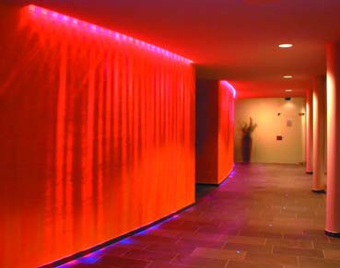

For LED modules DIN VDE 0715-100 applies (draft).

For fittings DIN IEC
60838-2-2 applies (draft).

For operating equipment DIN EN 61347-1 – A1 and A2 (drafts) apply,
as well as DIN
EN 61347-2-13 (draft).

For luminaires
DIN EN 60598-1,
DIN EN 60598-2 and
DIN EN 60825-1 apply.

The requirements for radiation safety in accor- dance with
DIN EN 60825-1 apply overall.

Standards for electro- magnetic tolerance
(EMV)

For LED modules, operational equipment and lights
DIN EN 55015, DIN EN 61547,
DIN EN 61000-3-2 and
DIN EN 61000-3-3 apply.

Illustration 77: the light and colour flooded wall attunes guests to the wellness
area of the Krallerhof Hotel in Leogang, Austria.
77

Illustration 78: light from the handrail guides passers-by over the bridge on the site of the
2005 North Rhine-Westphalia Garden Show in Leverkusen – an innovative use of light with LED lamps.
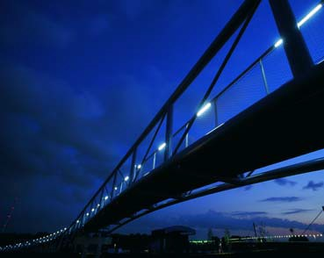

DIN VDE 0715-100 (draft) LED modules for general lighting – Safety requirements

DIN IEC 60838-2-2 (draft) Miscellaneous lampholders – Part 2: Particular requirements – connectors for LED modules.

DIN EN 61347-1 – A1 and A2 (drafts) Lamp controlgear – Part 1: General and safety requirements.

DIN EN 61347-2-13 (draft) Lamp controlgear –
Part 2-13: Particular requirements for d.c. or a.c. supplied electronic controlgears for LED modules

DIN IEC 62384 (in preparation) D.C. or A.C. supplied electronic control gear for LED modules – Performance requirements

DIN EN 60598-1 Luminaires – Part 1: General requirements and tests

DIN EN 60598-2 Luminaires – Part 2: Particular requirements

DIN EN 60825-1 Safety of laser products – Part 1: Equipment classification, requirements and user’s guide

DIN EN 55015 Limits and methods of measurement of radio disturbance characteristics of electrical lighting and similar equipment

DIN EN 61547 Equipment for general lighting purposes – EMC immunity requirements

DIN EN 61000-3-2 Electromagnetic compatibility (EMC) – Part 3-2:Limits – limits for harmonic current emissions (equipment input current 16A per phase)

DIN EN 61000-3-3 Electromagnetic compatibility (EMC) – Part 3-3: Limits – Limitation of voltage changes, voltage fluctuations and flicker in public low voltage supply sys- tems for equipment with rated current 16 A per phase and not subject to conditional connection

Illustrations 79 and 80: LEDs invite experimentation – coloured stripes or circles of light for enjoying a slide down the tubes.

LED definitions published by the product divisions Electric Luminaires and Electric Lamps of the German Electrical and Electronic Manufacturers Association ZVEI, Frankfurt am Main

LED in General Lighting – Optical Radiation Safety in Connection with Luminaires published by the product divisions Electric Luminaires and Electric Lamps of the German Electrical and Electronic Manufacturers Associa- tion ZVEI, Frankfurt am Main

Method for determing the life expectancies of LED- modules in electric luminaries published by the product divisions Electric Luminaires and Electric Lamps of the German Electrical and Electronic Manufacturers Associa- tion ZVEI, Frankfurt am Main

CE-Kennzeichnung für Leuchten, Lampen und Leuchtenzubehör – Ein Leitfaden zur Anwendung der relevanten EG-Richtlinien published (only in German) by the product divisions Electric Luminaires and Electric Lamps of the German Electrical and Electronic Manufac- turers Association ZVEI, Frankfurt am Main

Proceedings of the CIE Symposium ’04 on LED Light Sources: Physical Measurement and Visual Photo- biological Assessment, 7-8 June 2004, Tokyo/Japan, published as CIE-publication x026:2004 (ISBN 3-901
906-36-3)

Publications of the the German Electrical and Electronic
Manufacturers Association ZVEI are each available as
a download in the publications catalogue of the product divisions Electric Luminaires and Electric Lamps at www.zvei.org.
ZVEI, Stresemannallee 19, 60596 Frankfurt am Main, Germany

Publications of the CIE – Commission Internationale de l’Eclairage can be obtained from the CIE webshop at www.cie.co.at/cie/.
CIE Central Bureau, Kegelgasse 27, 1030 Vienna, Austria

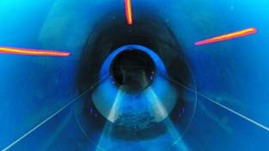
79 80
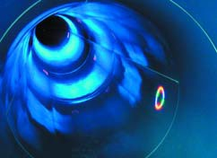

11
12
16
17
Fördergemeinschaft
Gutes Licht
Postfach 70 12 61
60591 Frankfurt am Main
Germany
05/06/00/17EpdfD

All illustrations were provided by member compa- nies of the Fördergemeinschaft Gutes Licht (FGL).
Postage
stamp

Further information on individual illustrations:
• Title illustration and illustrations 47 and 48: build- ing owner is the Aldopark Ltd in Weggis, Switzer- land. Photographs: Fabrikstudios Ltd, Lucerne.
Postcard
• Illustration 46: Gaetano Castelli stage set, transla- tion Nova Implanti 99.
• Illustrations 72 to 74: these show the ‘E-Komm Telecommunication Tower ‘ in Ludenscheid. Pho- tographs: Assunta Jaeger, Wuppertal.

Graphics

bs Werbung, Darmstadt: diagrams 2 to 7
FGL*: diagram 1
Kugelstadt MedienDesign, Darmstadt: diagrams 8 and 9

* provided by member companies of the
Name, Company, Office
Fördergemeinschaft Gutes Licht (FGL).
From
Department
c/o
Address or P.O. Box
City, Postal Code

Numbering of illustra- tions on back page:
The listed booklets are available in English only as pdf-file, download free of
charge at www.all-about-light.org:
1 Lighting with Artificial Light (7/04)
2 Good Lighting for Schools and Educational Establishments (7/03)
3 Good Lighting for Safety on Roads, Paths and Squares (3/00)
4 Good Lighting for Offices and Office Buildings (1/03)
6 Good Lighting for Sales and Presentation (2/02)
7 Good Lighting for Health Care Premises (4/04)
8 Good Lighting for Sports and Leisure Facilities (9/01)
Good Lighting for Hotels and Restaurants (2/05)
Lighting Quality with Electronics (5/03) Urban image lighting (4/02)–
LED – Light from the Light Emitting Diode (05/06)

81 | 82 | 83
84 | 85 | 86
87 | 88 | 89

Imprint
Bestellung
Bitte liefern Sie ohne weitere Nebenkosten die bezeichneten Hefte (e = available in English, E = available only as pdf-file, download at www.licht.de):

17
E E E
E
E E
E
E
E
E

This booklet is No. 17 in the series Information on Lighting Applications published by Fördergemeinschaft Gutes Licht (FGL) to provide information on good lighting with artificial light.

The titles and numbers of all the booklets in this series are shown on the page opposite.
The postcards on this page can be detached and used for ordering these booklets.

Orders can also be placed by e-mail (fgl@zvei.org) or via the Internet (www.licht.de). An invoice will be sent with the booklet(s) ordered.

Heft-Nr./Titel
1 Die Beleuchtung mit künstlichem Licht (7/04)
2 Gutes Licht für Schulen und Bildungsstätten (7/03)
3 Gutes Licht für Sicherheit auf Straßen, Wegen, Plätzen (3/00)
4 Gutes Licht für Büros und Verwaltungsgebäude (1/03)
5 Gutes Licht für Handwerk und Industrie (4/99)
6 Gutes Licht für Verkauf und Präsentation (2/02)
7 Gutes Licht im Gesundheitswesen (4/04)
8 Gutes Licht für Sport und Freizeit (9/01)
9 Repräsentative Lichtgestaltung (8/97)
10 Notbeleuchtung, Sicherheitsbeleuchtung (4/00)
11 Gutes Licht für Hotellerie und Gastronomie (12/04)
12 Beleuchtungsqualität mit Elektronik (5/03)
14 Ideen für Gutes Licht zum Wohnen (9/99)
16 Stadtmarketing mit Licht (4/02)
17 LED – Licht aus der Leuchtdiode (10/05) Lichtforum
R 9,– R 9,– R 9,– R 9,– R 9,– R 9,– R 9,– R 9,– R 9,– R 9,– R 9,– R 9,– R 9,– R 9,– R 9,–
kostenlos
Hefte 13 und 15 sind vergriffen
Ort
Bitte den Absender auf der Rückseite der Postkarte nicht vergessen.
Datum
Stempel/Unterschrift

Publisher: Fördergemeinschaft Gutes Licht (FGL) Stresemannallee 19
60596 Frankfurt am Main
Stück
Germany
phone: +49 (0)69 6302-353 fax: +49 (0)69 63 02-317
e-mail: fgl@zvei.org

Technical Fördergemeinschaft
consultant: Gutes Licht

Editing and rfw. redaktion für
The listed booklets are available in English only as pdf-file, download free of
charge at www.all-about-light.org:
11
12
16
17
realisation: wirtschaftskommunikation
1 Lighting with Artificial Light (7/04)
2 Good Lighting for Schools and Educational Establishments (7/03)
3 Good Lighting for Safety on Roads, Paths and Squares (3/00)
4 Good Lighting for Offices and Office Buildings (1/03)
6 Good Lighting for Sales and Presentation (2/02)
7 Good Lighting for Health Care Premises (4/04)
8 Good Lighting for Sports and Leisure Facilities (9/01)
Darmstadt
Good Lighting for Hotels and Restaurants (2/05)
Lighting Quality with Electronics (5/03) Urban image lighting (4/02)–
LED – Light from the Light Emitting Diode (05/06)

Design/DTP: Kugelstadt MedienDesign
Darmstadt

Lith film: Layout Service Darmstadt

Printed by: only available as pdf-file,
download at www.all-about-light.org

Acknowledgements: The booklets in this series contain references to current DIN standards and VDE stipulations.

DIN EN standards: Beuth-Verlag GmbH
10787 Berlin
Germany

DIN-VDE standards: VDE-Verlag
10625 Berlin
Germany

ISBN: 3-926 193-34-4

Reprints: With the permission of the publisher.
05/06/00/17EpdfD

Printed on chlorine-free bleached paper.

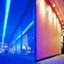


Fördergemeinschaft Gutes Licht (FGL) provides infor- mation on the advantages of good lighting and offers extensive material dealing
mit künstlichem Licht 1  Die Beleuchtung |  | und Bildungsstätten 2  Gutes Licht für Schulen |  | auf Straßen, Wegen, Plätzen 3  Gutes Licht für Sicherheit |  | Gutes Licht für Büros 4  und Verwaltungsgebäude

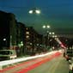

with every aspect of artificial lighting and its correct usage. FGL information is impartial and based on current DIN standards and VDE stipulations.
Handwerk und Industrie 5  Gutes Licht für |  | und Präsentation 6  Gutes Licht für Verkauf |  | Gesundheitswesen 7  Gutes Licht im |  | Sport und Freizeit 8  Gutes Licht für

Information on Lighting
Applications
The booklets 1 to 17 in this series of publications are designed to help anyone who becomes involved with lighting – planners, deci- sionmakers, investors – to acquire a basic knowledge of the subject. This facili- tates cooperation with lighting and electrical spe- cialists. The lighting infor- mation contained in all
these booklets is of a gen- eral nature.

Lichtforum
Lichtforum is a specialist periodical devoted to topical lighting issues and trends. It is published at irregular intervals. Lichtforum is available only in German.

www.all-about-light.org On the Internet, FGL offers tips on correct lighting for a variety of domestic and commercial ‘Lighting Applications’. In a Private Portal and a Pro Portal at www.licht.de, numerous ex- amples of applications are presented. Explanations of technical terms are also available at the click of a mouse on the buttons
‘About Light’ and ‘Lighting Technology’. Databases containing a wealth of product data, a product/ supplier matrix and the addresses of FGL members provide a direct route
to manufacturers. ‘Publica- tions’ in an online shop and
‘Links’ for further informa- tion round off the broad spectrum of the FGL light portal.

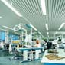

Repräsentative

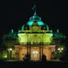
Bauten und Anlagen 13  Gutes Licht für kommunale |  | zum Wohnen 14  Ideen für Gutes Licht |  | am Haus und im Garten 15  Gutes Licht |  | Stadtmarketing mit Licht 16

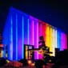
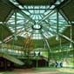
Lichtgestaltung 9 |  | Sicherheitsbeleuchtung 10 |  | und Gastronomie 11 |  | mit Elektronik 12

LED – Licht aus der Leuchtdiode
17

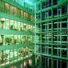
Notbeleuchtung
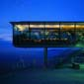

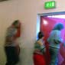



Gutes Licht für Hotellerie


Beleuchtungsqualität

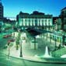

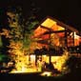

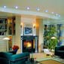

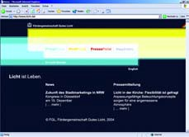
Booklets 13 and 15 are out of print

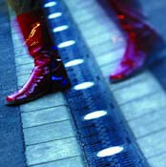
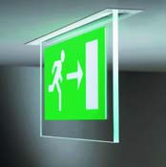
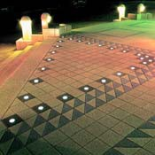

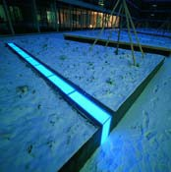
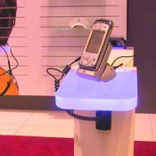
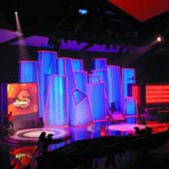
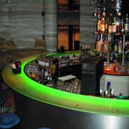
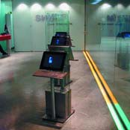
Information
on lighting applications
Booklet
17

LED – Light from the Light Emitting Diode

Fördergemeinschaft Gutes Licht

